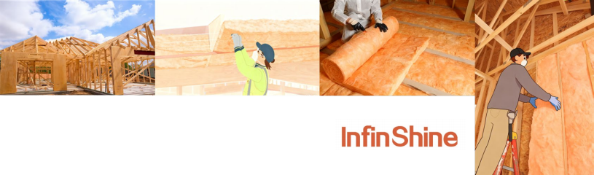
InfinShineTM Glass Wool Insulation Batts

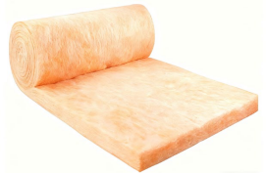
Safety, Eco-friendliness, Sound Absorption, Light Weight

Description
Glass Wool Insulation Batts are fiberglass insulation products designed around an environmental protection concept. They prioritize high-efficiency insulation and sustainability, making them suitable for walls, roofs, celling and other areas in
residential and commercial buildings. These batts deliver solutions for building energy efficiency and green living.
Features & Benefits
Safe, Proven Ingredients: Meets strict safety benchmarks for consistent long-term performance.
Non-Combustible: Fire-resistant to prevent ignition in emergencies, boosting protection.
Sound-Absorbing: Dampens rain noise outdoors, reducing indoor disturbance for quietness.
Easy Installation: Lightweight, flexible design enables quick setup (even for non-professionals).
Cost-Effective: Enhances home comfort with low costs for long-term value.
Sustainable: Made with ≥80% recycled glass to cut landfill waste, supporting eco-practices.
GREENGUARD Gold Certified: Meets low-emission standards for healthier air (ideal for families, seniors, allergy sufferers).
Compression packaging for easier handling and reduced volume.
Uses
u Wood-framed wall, floor, and roof/ceiling cavity applications.
u Metal-framed wall and floor cavity applications.
u Interior surfaces of basement and unvented crawl space foundation walls.
Technical Data
PROPERTY | VALUE | TEST METHOD
Corrosion of Steel | Pass | C1617
Non-combustibility | Complies | CAN/ULC-S114
Smoulder Resistance Corrosion | Average Mass Loss ≤ 2%, Individual Mass Loss ≤ 3% | CAN/ULC-S129
Surface Burning Characteristics | Flame Spread 0; Smoke Developed 0 | CAN/ULC-S102
Fungi Resistance | Pass | ASTM C1338

Specification

THERMAL  RESISTANCE |  | APPLICATION | THICKNESS | WIDTH | LENGTH | COVERAGE/  BAG
RSI | R |  |  |  |  | SQ. M. | SQ. FT.
2.1 | 12 | Wood Frame | 89 mm (3.5") | 279 mm (11") | 1219 mm (48") | 13.65 | 146.7
 |  |  |  | 381 mm (15") | 1194 mm (47") | 9.1 | 97.9
 |  |  |  |  | 1219 mm (48") | 9.29 | 100
 |  |  |  | 584 mm (23") | 1194 mm (47") | 13.95 | 150.1
 |  |  |  |  | 1219 mm (48") | 14.24 | 153.3
2.1 | 12 | Steel Frame | 92 mm (3.625") | 406 mm (16") | 1219 mm (48") | 9.91 | 106.7
 |  |  |  | 610 mm (24") | 1219 mm (48") | 14.86 | 160
2.4 | 14 | Wood Frame | 89 mm (3.5") | 381 mm (15") | 1194 mm (47") | 7.28 | 78.3
 |  |  |  | 584 mm (23") | 1194 mm (47") | 11.16 | 120.1
2.4 | 14 | Steel Frame | 92 mm (3.625") | 413 mm (16.25") | 1219 mm (48") | 8.05 | 86.7
3.5 | 20 | Steel Frame | 152 mm (6") | 406 mm (16") | 1219 mm (48") | 7.93 | 85.3
 |  |  |  | 610 mm (24") | 1219 mm (48") | 11.89 | 128
3.9 | 22 | Wood Frame | 140 mm (5.5") | 381 mm (15") | 1194 mm (47") | 4.55 | 49
 |  |  |  | 584 mm (23") | 1194 mm (47") | 6.97 | 75.1
4.2 | 24 | Wood Frame | 140 mm (5.5") | 375 mm (14.75") | 1194 mm (47") | 3.13 | 33.7
 |  |  |  | 578 mm (22.75") | 1194 mm (47") | 4.83 | 52
4.2 | 24 | Steel Frame | 152 mm (6") | 413 mm (16.25") | 1219 mm (48") | 3.52 | 37.9
4.9 | 28 | Unrestricted  Cavity | 216 mm (8.5") | 381 mm (15") | 1219 mm (48") | 4.64 | 50
 |  |  |  | 406 mm (16") | 1219 mm (48") | 4.95 | 53.3
 |  |  |  | 610 mm (24") | 1219 mm (48") | 7.43 | 80
4.9 | 28 | Cavity  Restricted | 178 mm (7") | 381 mm (15") | 1219 mm (48") | 2.79 | 30
 |  |  |  | 584 mm (23") | 1219 mm (48") | 4.27 | 46
Certifications and Sustainable Features
GREENGUARD GOLD Certified products are certified to GREENGUARD standards for low chemical emissions into indoor air during product usage.

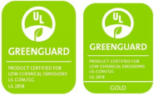
In fin shine |  |  | Shanghai Infinshine New Materials Technology Co., Ltd.  Room 108, Building 1, No. 5158 Jinshan Avenue, Jinshan District, Shanghai, China  Postal Code: 201500

